**Assignment 1 – Machine Learning (Blended Del)**

**Student No.: 23211267**

**Name: Conor Heffron**

**Module Code: COMP47460**

**1.1.**

**Examine the dataset carefully in the Weka Explorer. You should investigate some of the [5] filters in Weka which allow you to normalise and/or clean the dataset as appropriate. Describe the data preparation/cleaning steps you took if any (e.g., Your description may look like ”I did min-max normalisation of feature X using the minimum on the feature values in training examples and maximum of feature values over all labelled examples. I manually removed feature Y because …”).**

* **Note: Please see uploaded python scripts for incremental output csv files and console output outlined below. In addition, I have taken one of the earlier output files and updated with excel functions to ensure code matches manually calculated results.**
* I loaded the dataset into Weka and exported to csv format.
* There were 2115 records or instances loaded from the *.arff file with 22 attributes or features.
* Straight away I could see ‘severe_decelerations’ was a very limited feature with only 2 distinct values where a non-zero value only occurs 7 times as noted by the python scripts output below (z sum = 7.0 after normalising to range [0, 1]) so I removed this feature from further analysis in Weka and python script runs.
* I think the histogram features would normally be dropped but some of them appear to be quite varied so this makes for a good data sample.



‘mean_value_of_long_term_variability’ has the most distinct values at 249 which was something to note.



Then I wrote Python code to clean and normalise the data especially the numerical features.

I then calculated the z value for each and ordered by z sum as the final program output to see the key features from this process.

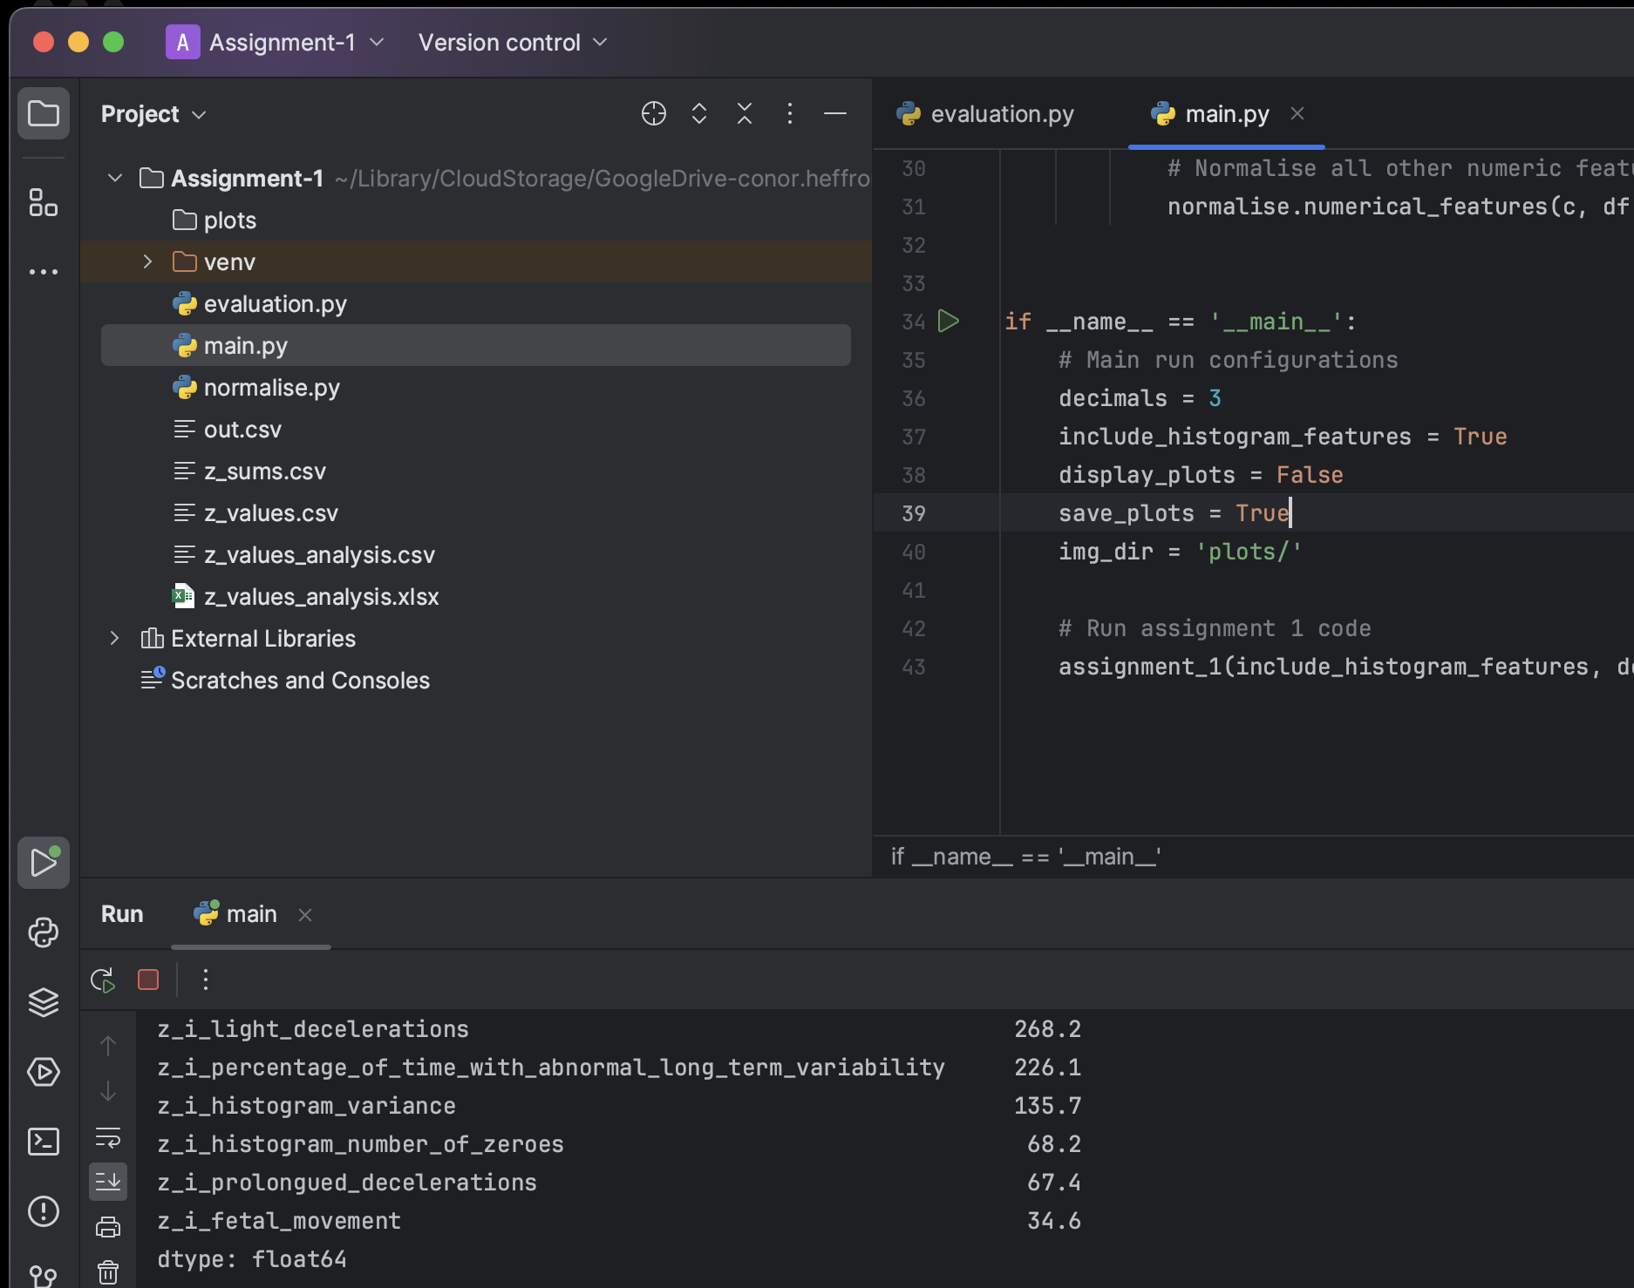



**Note:** From top left above marked with red:

* plots output directory
* python scripts,
* incremental output files
* manual excel analysis for comparison
* Main configurations for python run script

**Main Program Console Out:**

------------------------------------------------

Min of baseline_value is: 106

Max of baseline_value is: 160

Mean of baseline_value is: 133.30070921985816

Median of baseline_value is: 133.0

Standard Deviation of baseline_value is: 9.837149600812499

Zi sum value baseline_value is: 1074.6

------------------------------------------------

Min of accelerations is: 0.0

Max of accelerations is: 0.019

Mean of accelerations is: 0.0031787234042553194

Median of accelerations is: 0.002

Standard Deviation of accelerations is: 0.003863961682425237

Zi sum value accelerations is: 367.79999999999995

------------------------------------------------

Min of fetal_movement is: 0.0

Max of fetal_movement is: 0.481

Mean of fetal_movement is: 0.009526713947990545

Median of fetal_movement is: 0.0

Standard Deviation of fetal_movement is: 0.046782681829283676

Zi sum value fetal_movement is: 34.599999999999994

------------------------------------------------

Min of uterine_contractions is: 0.0

Max of uterine_contractions is: 0.015

Mean of uterine_contractions is: 0.004373049645390071

Median of uterine_contractions is: 0.004

Standard Deviation of uterine_contractions is: 0.002947399462280164

Zi sum value uterine_contractions is: 616.8

------------------------------------------------

Min of light_decelerations is: 0.0

Max of light_decelerations is: 0.015

Mean of light_decelerations is: 0.001888888888888889

Median of light_decelerations is: 0.0

Standard Deviation of light_decelerations is: 0.0029635828830450834

Zi sum value light_decelerations is: 268.20000000000005

------------------------------------------------

~~Min of severe_decelerations is: 0.0~~

~~Max of severe_decelerations is: 0.001~~

~~Mean of severe_decelerations is: 3.309692671394799e-06~~

~~Median of severe_decelerations is: 0.0~~

~~Standard Deviation of severe_decelerations is: 5.744822913623554e-05~~

~~Zi sum value severe_decelerations is: 7.0~~

------------------------------------------------

Min of prolongued_decelerations is: 0.0

Max of prolongued_decelerations is: 0.005

Mean of prolongued_decelerations is: 0.00015933806146572102

Median of prolongued_decelerations is: 0.0

Standard Deviation of prolongued_decelerations is: 0.0005913692853366418

Zi sum value prolongued_decelerations is: 67.4

------------------------------------------------

Min of abnormal_short_term_variability is: 12

Max of abnormal_short_term_variability is: 87

Mean of abnormal_short_term_variability is: 46.95035460992908

Median of abnormal_short_term_variability is: 49.0

Standard Deviation of abnormal_short_term_variability is: 17.162584263361758

Zi sum value abnormal_short_term_variability is: 983.9

------------------------------------------------

Min of mean_value_of_short_term_variability is: 0.2

Max of mean_value_of_short_term_variability is: 7.0

Mean of mean_value_of_short_term_variability is: 1.3339952718676122

Median of mean_value_of_short_term_variability is: 1.2

Standard Deviation of mean_value_of_short_term_variability is: 0.8837077165359826

Zi sum value mean_value_of_short_term_variability is: 345.20000000000005

------------------------------------------------

Min of percentage_of_time_with_abnormal_long_term_variability is: 0

Max of percentage_of_time_with_abnormal_long_term_variability is: 91

Mean of percentage_of_time_with_abnormal_long_term_variability is: 9.823167848699764

Median of percentage_of_time_with_abnormal_long_term_variability is: 0.0

Standard Deviation of percentage_of_time_with_abnormal_long_term_variability is: 18.391154458995572

Zi sum value percentage_of_time_with_abnormal_long_term_variability is: 226.10000000000002

------------------------------------------------

Min of mean_value_of_long_term_variability is: 0.0

Max of mean_value_of_long_term_variability is: 50.7

Mean of mean_value_of_long_term_variability is: 8.19886524822695

Median of mean_value_of_long_term_variability is: 7.4

Standard Deviation of mean_value_of_long_term_variability is: 5.636014802636036

Zi sum value mean_value_of_long_term_variability is: 339.70000000000005

------------------------------------------------

Min of histogram_width is: 3

Max of histogram_width is: 180

Mean of histogram_width is: 70.49267139479906

Median of histogram_width is: 68.0

Standard Deviation of histogram_width is: 38.95078910381832

Zi sum value histogram_width is: 807.9000000000001

------------------------------------------------

Min of histogram_min is: 50

Max of histogram_min is: 159

Mean of histogram_min is: 93.54704491725768

Median of histogram_min is: 93.0

Standard Deviation of histogram_min is: 29.580143601297536

Zi sum value histogram_min is: 844.7

------------------------------------------------

Min of histogram_max is: 122

Max of histogram_max is: 238

Mean of histogram_max is: 164.03971631205673

Median of histogram_max is: 162.0

Standard Deviation of histogram_max is: 17.944182664569215

Zi sum value histogram_max is: 768.3

------------------------------------------------

Min of histogram_number_of_peaks is: 0

Max of histogram_number_of_peaks is: 18

Mean of histogram_number_of_peaks is: 4.069976359338061

Median of histogram_number_of_peaks is: 3.0

Standard Deviation of histogram_number_of_peaks is: 2.947638560550025

Zi sum value histogram_number_of_peaks is: 492.3

------------------------------------------------

Min of histogram_number_of_zeroes is: 0

Max of histogram_number_of_zeroes is: 10

Mean of histogram_number_of_zeroes is: 0.3224586288416076

Median of histogram_number_of_zeroes is: 0.0

Standard Deviation of histogram_number_of_zeroes is: 0.7041179104063311

Zi sum value histogram_number_of_zeroes is: 68.20000000000002

------------------------------------------------

Min of histogram_mode is: 60

Max of histogram_mode is: 187

Mean of histogram_mode is: 137.44586288416076

Median of histogram_mode is: 139.0

Standard Deviation of histogram_mode is: 16.403044334341104

Zi sum value histogram_mode is: 1289.5

------------------------------------------------

Min of histogram_mean is: 73

Max of histogram_mean is: 182

Mean of histogram_mean is: 134.60614657210402

Median of histogram_mean is: 136.0

Standard Deviation of histogram_mean is: 15.617939011476754

Zi sum value histogram_mean is: 1198.4999999999998

------------------------------------------------

Min of histogram_median is: 77

Max of histogram_median is: 186

Mean of histogram_median is: 138.09078014184396

Median of histogram_median is: 139.0

Standard Deviation of histogram_median is: 14.48426821225838

Zi sum value histogram_median is: 1184.8

------------------------------------------------

Min of histogram_variance is: 0

Max of histogram_variance is: 269

Mean of histogram_variance is: 18.846808510638297

Median of histogram_variance is: 7.0

Standard Deviation of histogram_variance is: 29.03532873969992

Zi sum value histogram_variance is: 135.7

------------------------------------------------

Min of histogram_tendency is: -1

Max of histogram_tendency is: 1

Mean of histogram_tendency is: 0.32056737588652484

Median of histogram_tendency is: 0.0

Standard Deviation of histogram_tendency is: 0.6107888873223769

Zi sum value histogram_tendency is: 1396.5

------------------------------------------------

z_i_fetal_health 1499.7

**z_i_histogram_tendency 1396.5**

**z_i_histogram_mode 1289.5**

**z_i_histogram_mean 1198.5**

**z_i_histogram_median 1184.8**

**z_i_baseline_value 1074.6**

**z_i_abnormal_short_term_variability 983.9**

**z_i_histogram_min 844.7**

z_i_histogram_width 807.9

z_i_histogram_max 768.3

z_i_uterine_contractions 616.8

z_i_histogram_number_of_peaks 492.3

z_i_accelerations 367.8

z_i_mean_value_of_short_term_variability 345.2

z_i_mean_value_of_long_term_variability 339.7

z_i_light_decelerations 268.2

z_i_percentage_of_time_with_abnormal_long_term_variability 226.1

z_i_histogram_variance 135.7

z_i_histogram_number_of_zeroes 68.2

z_i_prolongued_decelerations 67.4

z_i_fetal_movement 34.6

~~z_i_severe_decelerations 7.0~~

dtype: float64

Process finished with exit code 0

* ‘fetal_health’ value is the categorical feature that was originally used to classify the data so I have excluded this as a key feature but more like a classifier field.
* The 7 key features thereafter and info are highlighted in yellow.
* The next 3 fields highlighted in orange were non histogram related fields.
* The features with z sum less than 40 are marked in blue. I removed ‘severe_decelerations’ altogether as I don’t think it’s even close to the threshold to be very useful. However out of the seven non zero values there were 6 records with the same fetal health classifier assigned but this is probably coincidence as the data sample is too small.

Output Verified in Excel Worksheet after manually manipulating incremental csv output files:

**1.2.**

**Use 3 classifiers [k-NN, Naive Bayes, Decision Tree] we have discussed in the module [20] and compare the accuracy of the Fetal Health predictions. You should choose the accuracy measures, explain your choices, and discuss some reasons for the different accuracy values. What is the optimal value of k for the k-NN classifier?**

**Do you get better accuracy if you use 1/d weighting? Do the results change if you use k = 3 or k = 5-fold cross-validation?**

* Naïve Bayes is least accuracte.
* KNN and decision tree are close in accuracy (over 95% so good options).
* Running with k=1, then k=3 and k=5 improved accuracy each time when updating to use 1/distance weighting.

Naive Bayes



Decision Tree



k-NN



**1.3.**

**i. Plot the ROC curves for 3 different classification models (use Weka for this). [15]**

**ii. What do you learn from these ROC curve? Include the AUC in your discussion.**

**iii. Which classifier/configuration is best suited for this task? Are you satisfied with the performance?**

Weka Plots and visualisation notes:

**1.4.**

**This dataset has many features. Carefully identify the most discriminating features to [20] predict Fetal Health.**

Top 14 features after normalisation of numerical features (top 6 non histogram features in bold / red)

1. histogram_tendency
2. histogram_mode
3. histogram_mean
4. histogram_median
5. **baseline_value**
6. **abnormal_short_term_variability**
7. histogram_min
8. histogram_width
9. histogram_max
10. **uterine_contractions**
11. histogram_number_of_peaks
12. **accelerations**
13. **mean_value_of_short_term_variability**
14. **mean_value_of_long_term_variability**

**1.5.**

**Use the following methods in Weka to find the top 5 features:**

**• Wrapper + forward search**



1. accelerations

2. prolonged_decelerations

3. abnormal_short_term_variability

4. mean_value_of_short_term_variability

5. percentage_of_time_with_abnormal_long_term_variability

~~6. histogram_mean~~

**• Wrapper + backwards search**



1. accelerations

2. prolonged_decelerations

3. abnormal_short_term_variability

4. mean_value_of_short_term_variability

5. percentage_of_time_with_abnormal_long_term_variability

~~6. histogram_mean~~

**• Information Gain Discuss the differences in the selected sets of features.**



1. mean_value_of_short_term_variability

2. percentage_of_time_with_abnormal_long_term_variability

3. abnormal_short_term_variability

4. histogram_mean

5. histogram_variance

~~6. histogram_mode~~

**1.6.**

**Evaluate the performance of the [Decision Tree, Naive Bayes, k-NN] classifiers with the [20] top 5 features selected in the previous part. Comment on the differences you observe in the performance.**

Wrapper search forward and backward produce the same top 5 fields.

IG produces are different and more accurate top 5 feature list for what I have compared to up to this point.

**1.7.**

**Use Weka to extract the top 2 Principal Components. Evaluate the performance of the [20] [Decision Tree, Naive Bayes, k-NN] classifiers with these principal components and comment on any differences with previous methods. Visualise the principal components (you can add a screenshot of Weka) and comment on how they match with your expectations, having run various models and feature selections.**

